**Indira College of Engineering and Management Pune**



# Food order system

Project By -

**Nainesh Gopalrao Iche – 82123**

Under the Guidance of -

**Dr. Darshana Desai Ma’am**

**Index**

1. **Abstract**
2. **Introduction**
3. **Existing System And Need Of The System:**
4. **Future Scope Of The System:**
5. **Software Requirements:**
6. **Hardware Components:**
   * + **PC Laptop Configuration**
     + **Android ( Linux kernel ) Configuration**
7. **Technologies Used:**
8. **Proposed System:**
9. **Advantages:**
10. **Disadvantages:**
11. **Objectives Of The System:**
12. **Food Ordering System Module**
13. **Conclusion:**

# Abstract

ONLINE FOOD ORDER SYSTEM is a Android Application designed primarily for use in the food delivery industry. This system will allow hotels and restaurants to increase scope of business by reducing the labor cost involved. The system also allows to quickly and easily manage an online menu which customers can browse and use to place orders with just few clicks. Restaurant employees then use these orders through an easy to navigate graphical interface for efficient processing.

**Introduction**

In a modern generation Online food ordering is a mobility of food delivery or takeout from a local restaurant or food cooperative. Now days the rapid growth in the use of internet and the technologies associated with it, the several opportunities are coming up on the web or mobile application. This is made possible through the use of electronic payment system (UPI) Unified Payment Interface. The payment can be done through the customer’s credit card, debit card. It is possible for everyone to order any goods from anywhere the internet and have the goods delivered at his/her home. By the connecting to the more Restaurants it will give the customers the variety of foods. With this method, food is ordered online and delivered to the customer. The system will become an important tools use for restaurant to improve the management aspect by use of computer system to connected each and every food ordering transaction instead of data record on it. In addition, it can also provide efficiency for the restaurant by reducing time, minimize human errors or delivery and providing good quality and service to customers. In terms of the integrity and availability of the system provided, it can be concluded that this system is a suitable solution.

## Existing System and Need of the System:

In the present scenario, people have to physically visit the hotels or restaurants for eating food and have to make payments through cash mode most of the time due to unawareness of advanced technologies at certain places. In this method time as well as physical work is required, among which time is something that no one has in ample amount.

The traditional food ordering procedure is not efficient enough for hotels and restaurants, as they have to deal with the crowd, in their restaurant. The old methods can be classified into categories which are paper grounded and verbal grounded. For paper-based work, the waiter comes and pens down foods that customers order and pass the food list containing paper to the chefs or cooks in the kitchen for further process.

Also, from the owner’s point of view maintaining data records and the accounts in the physical file are quite difficult and tedious work to do. And also, it is full of risk as anyone can access it and modify the data.

## Future Scope of the System:

This order food online system project aimed at developing an online food ordering system that can be used in small places, and medium cities firstly and then on a large scale. It is developed to help restaurants to simplify their daily operational and managerial task as well as improve the dining experience of customers.

And also helps restaurants develop healthy customer relationships by providing good services. The system enables staff to let update and make changes to their food and beverage list information based on the orders placed and the orders completed.

**Software Requirements:**

* Windows 7, Windows 10.
* Android Studio, Visual Studio Code.
* Linux Kernel.
* Firebase DB

**Hardware Requirements:**

**PC Laptop Configuration**

* Processor – i3 or any higher version
* Hard Disk – 10 GB or more
* RAM – 8GB RAM or more

**Android ( Linux kernel ) Configuration**

* Android Version – Above Android 6.0 (Marshmallow)
* Storage – 30 MB or more
* RAM – 2GB RAM or more

**Technologies Used:**

* Front-end Design [ Android Studio (JAVA) ], Android Studio Code.
* DataBase [ Firebase ]

**Proposed of the System:**

This system is a bunch of benefits from various points of view. This online application enables the end-users to register to the system online, select the food items of their choice from the menu list, and order food online. Also, the payment can be made through online mode or at the time of home delivery depending upon the customer’s choice and convenience.

The selection made by the customers will be available to the hotel reception or to the person handling the work assignment. Now this same person will assign the orders to the specialist chef to be completed within a fixed duration of time. As soon as the chef prepares the food, the later person forwards the parcels to the delivery persons assigned with the location and customer identity of the customer along with the bill status.

One of the various benefits of this is system is that if there is a rush or a huge crowd present in the restaurant then in that case sometimes unavailability of tables cut downs the restaurant’s customer.

Also, there will be chances that the waiters are unavailable as they are busy handling others, so the customer can directly order the food to the chef online by using this application, by checking the seat availability in the restaurant. This system allows the staff to serve customers within less time as compared to the manual system.

**Advantages:**

### Make the order Process Easier

### Ladies, You Can Enjoy The Parties Too!

### Urban Restaurants, Reach Out to Remote Foodies

**Disadvantages:**

### Deliverymen Put Themselves in Danger

### Disguised Increased Expense

### Revenue Conflicts Between The Restaurants and Delivery Providers

### Juggling With Your Health

**Objectives of the System:**

The main objective of the Online Food Ordering System is to manage the details of Item Category Food Delivery Address, Order Shopping Cart. It manages all the information about Item Category, Customer, Shopping Cart, Item Category. The project is totally built at administrative end and thus only the administrator is guaranteed the access. The purpose of the project is to build an application program to reduce the manual work for managing the item Category Food Customer, Delivery Address. It tracks all the details about the Delivery Address Order Shopping Cart.

##### **Food Ordering System Module**

This module provides the functionality for customers to place their order and supply necessary details. Users of the system, namely restaurant customers, must be provided the following functionality:

* Create an account.
* Manage their account.
* Log in to the system.
* Navigate the restaurant’s menu.
* Select an item from the menu.
* Add an item to their current order.
* Review their current order.
* Remove an item/remove all items from their current order.
* Provide payment details.
* Place an order.
* Receive confirmation in the form of an order number.
* View order placed.

**Menu Management System Module**

This module provides functionality for the power user-Administrator only. It will not be available to any other users of the system like Restaurant Employees or Customers.

Using a graphical interface, it will allow an Admin to manage the menu that is displayed to users of the web ordering system:

* Add/update/delete food category to/from the menu.
* Add /update/delete food item to/from the menu.
* Update price for a given food item.
* Update additional information (description, photo, etc.) for a given food item.

Before customers can actually use this system, functionality provided by this component will have to be configured first. Once the initial configuration is done, this will be the least likely used component as menu updates are mostly seasonal and do not occur frequently.

##### **Order Retrieval System Module**

This is the most simplest module out of all 3 modules. It is designed to be used only by restaurant employees, and provides the following functions:

* Retrieve new orders from the database.
* Display the orders in an easily readable, graphical way.

##### **Functional Requirement Specifications:**

**Activity Diagram (Admin):**

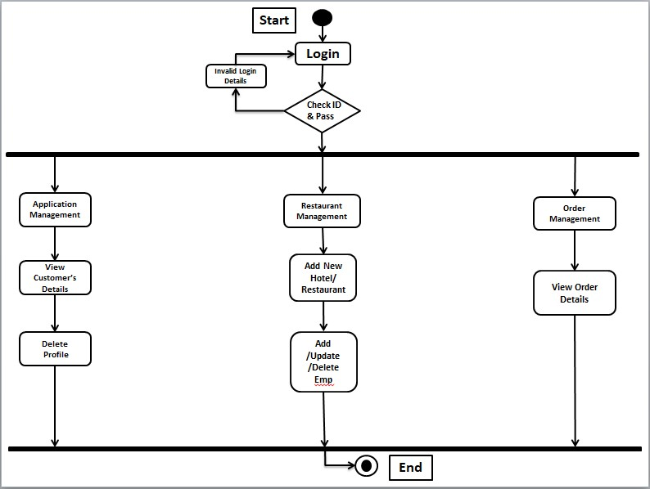

**Activity Diagram (Customer):**

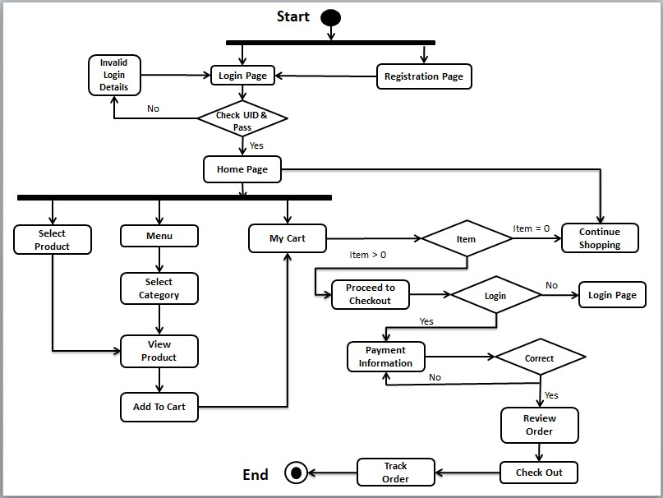

**Use Case Diagram:**

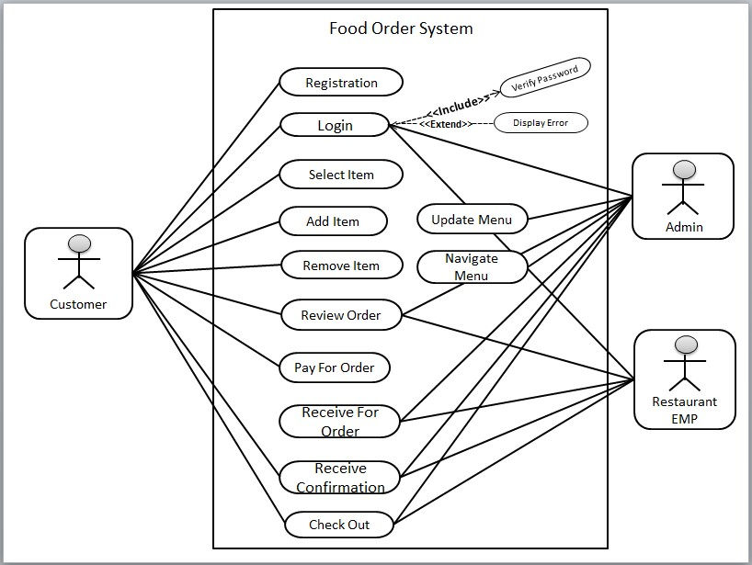

**E-R Diagram:**

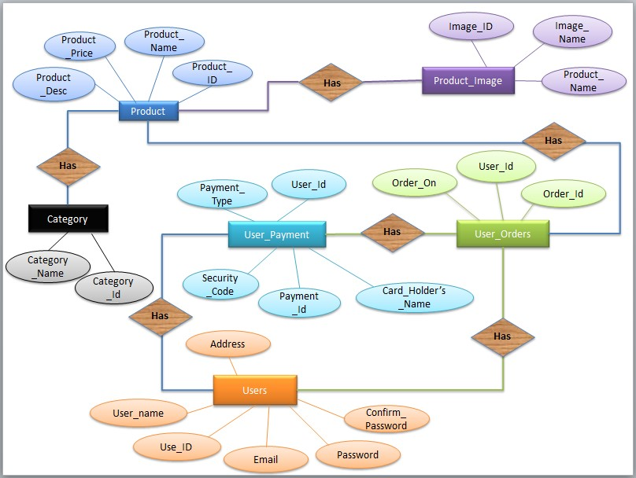

**Class Diagram:**

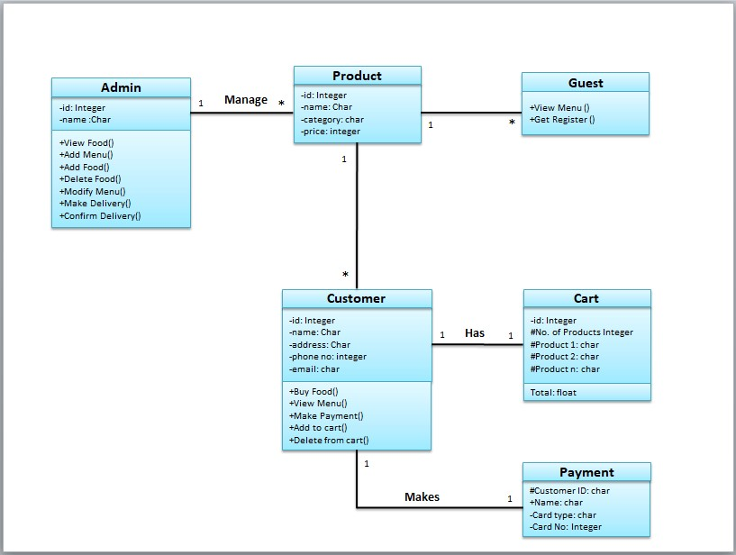

**Module Hierarchy Diagram:**

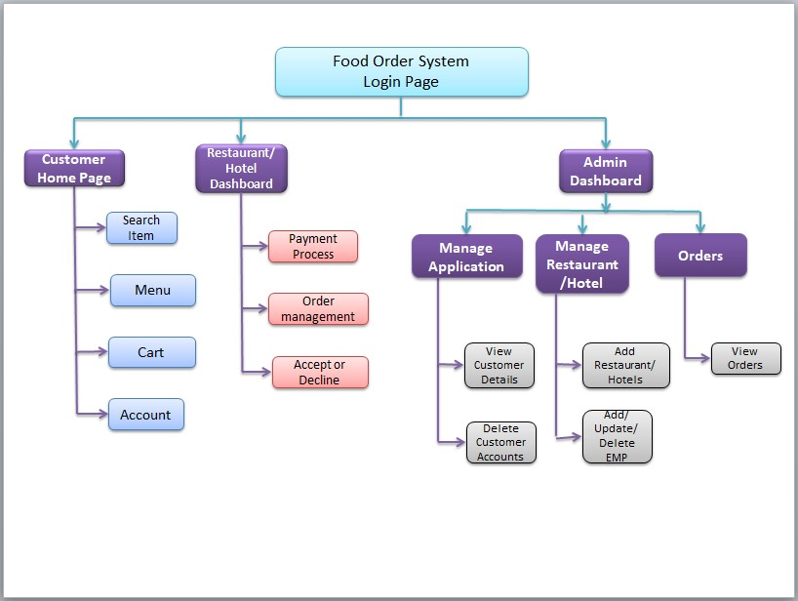

**Conclusion:**

So, this is the overall process of making the Online Shopping system worked, and the user can get the policy without any headache of the agent and sometimes do not need to provide a commission to them.